Member 2
Q2
1)Requirement and scope
Defining requirements and scope is one of the most critical early decisions in the software lifecycle, as it establishes the project boundaries and sets the foundation for all subsequent activities. This decision is brought in at the very beginning of the project and becomes operationally significant throughout its duration. To make a sound decision, project teams must gather information such as user needs, business goals, regulatory requirements, feasibility studies and stakeholder interviews. Clear requirements directly enable design, architecture, testing and project planning, while poorly defined scope often leads to scope creep and costly rework. Evidence from the Project Management Institute’s Pulse of the Profession 2024 Report highlights this risk, noting that 32% of projects experienced scope creep and 12% failed outright (Pierre Le Manh, 2024), underscoring the importance of addressing requirements and scope early in the lifecycle.

2)Methodology and process
Choosing the right methodology and process is a crucial early decision in the software lifecycle because it aligns the team’s workflow and sets the rhythm for project execution. This decision should be considered at project initiation, before development begins and becomes operationally significant during planning and the early development sprints. To make a sound choice, teams must evaluate factors such as team size, project complexity, stakeholder involvement and delivery timelines. The selected methodology directly influences project scheduling, communication, testing approaches and delivery cadence, while poor alignment can lead to delivery friction and inefficiencies. Evidence from the Project Management Institute’s Pulse of the Profession 2024 Report reinforces this point, showing that projects using agile or adaptive methods achieved a 73% success rate compared to traditional approaches (Pierre Le Manh, 2024), highlighting the importance of methodology selection at the outset.

3)Stakeholder Alignment
Stakeholder alignment is a vital early decision in the software lifecycle because it ensures a shared vision and prevents conflicting goals from derailing the project. This consideration begins at the requirements gathering stage and remains operationally significant throughout requirements validation and design approval. To make a sound decision, project teams must understand stakeholder goals, priorities, success metrics and communication preferences. Effective alignment enables requirements validation, design sign-off, acceptance testing and change management, while poor alignment often results in conflicting objectives and project delays. As Kerzner’s Project Management Handbook (Nieto-Rodriguez, 2021) emphasizes, lack of stakeholder alignment and weak sponsorship are major causes of project failure (Nieto-Rodriguez, 2021), highlighting the importance of securing stakeholder consensus early in the lifecycle.

4)Security and Compliance
Security and compliance are critical decisions that must be addressed early in the software lifecycle to protect data and maintain user trust. These considerations should be introduced at the system design stage, before coding begins, and remain operationally significant throughout architecture, coding and deployment phases. To make sound decisions, teams must account for applicable regulations such as GDPR or HIPAA, conduct threat modelling, assess data sensitivity and define authentication requirements. Early attention to these factors directly influences database design, API development, testing, deployment and ongoing maintenance. Neglecting security and compliance can result in breaches and costly fines, while proactive planning reduces long-term risks. Evidence from IBM’s Cost of a Data Breach Report 2023 demonstrates that organizations incorporating security design early significantly lower breach costs, reinforcing the importance of embedding compliance and security considerations from the outset (IBM Security, 2023).

5)Integration
Integration is a critical decision in the software lifecycle because it ensures compatibility between systems and prevents costly redesigns later. This concern should be addressed during system design and architecture planning and it becomes operationally significant when APIs and interfaces are developed and tested. To make sound integration decisions, teams must consider existing systems, interoperability standards, API specifications and vendor dependencies. These choices directly affect system testing, deployment and long-term scalability, while poor planning often results in redesigns and delays. Gartner reports emphasize that integration challenges are among the top drivers of IT project overruns, underscoring the importance of addressing compatibility and interoperability early in the lifecycle.

6)Maintenance
Maintenance is a fundamental decision in the software lifecycle because it sustains the product and ensures its long-term viability. This concern should be considered as early as the design stage, before implementation and becomes operationally significant post-deployment during support and updates. To make sound maintenance decisions, teams must plan versioning strategies, establish documentation standards, allocate support resources and define a long-term roadmap. These choices directly affect bug fixing, patching, upgrades and user support, while neglecting maintenance planning often results in high long-term costs. Evidence from IEEE Software Engineering studies confirms that maintenance consumes between 60–80% of total lifecycle costs (Haleem, 2023), highlighting the importance of embedding maintenance considerations into the design phase to reduce future burdens.

Decision Horizon Map
(created in PowerPoint because I have no idea how to do it in Microsoft Word)
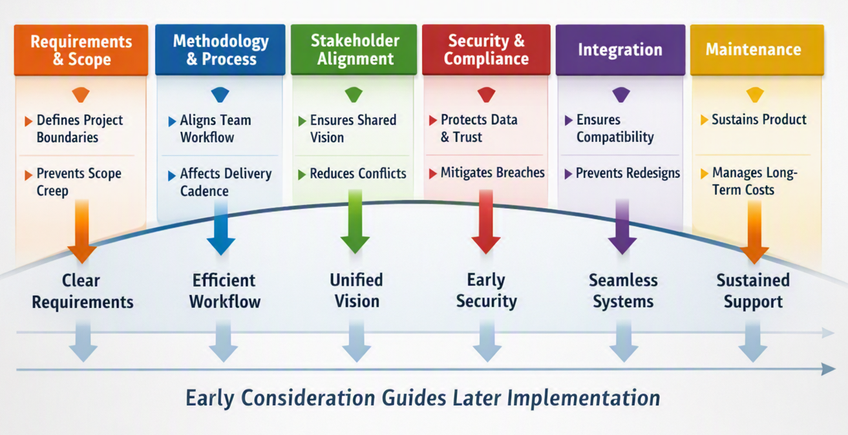

Q4 (the 3 risks with AI)
1) Bias and Reliability of Outputs
One significant risk of AI-assisted engineering is the presence of bias and reliability issues in its outputs. Because AI systems are trained on historical data, they can inherit biases or reflect incomplete information. This can lead to skewed engineering decisions, such as overlooking critical safety factors or misallocating resources. For example, if the training data underrepresents certain failure scenarios, the AI may fail to predict them, resulting in unsafe designs.

2) Over-dependence and Reduced Human Oversight
Another limitation is the danger of over-dependence on AI, which can reduce human oversight and accountability. Engineers may rely too heavily on AI recommendations without critically evaluating them, allowing flawed or unsafe solutions to pass unchecked. In safety-critical fields such as aerospace or medical devices, blind reliance on AI outputs could have catastrophic consequences if the system makes an error. Human judgment and validation remain essential to ensure that AI suggestions are sound and trustworthy.

3) Transparency and Explainability Limitations
A third risk lies in the transparency and explainability of AI systems. Many advanced models, particularly deep learning, operate as “black boxes,” making it difficult to understand how they reach conclusions. This lack of explainability undermines trust, complicates regulatory approval, and makes debugging or auditing engineering decisions challenging. For instance, if an AI proposes a design change but cannot explain its reasoning, engineers may struggle to justify the decision to stakeholders or regulators.

References
Haleem, M., 2023. A Critical Review for Software Maintenance Cost Estimation Models: A Data Driven Approach, s.l.: IEEE.
IBM Security, 2023. Cost of a data breach report 2023, s.l.: IBM Security.
Nieto-Rodriguez, A., 2021. Harvard Business Review. 2021 ed. s.l.:Harvard Business school Publishing Corporation.
Pierre Le Manh, 2024. Pulse of the Profession, s.l.: University of Southampton Institutional Repository.

